

Forecasting Harveston's Climate Variables for Agricultural Adaptation

By simpleCoders - Data_Crunch_012
University of Ruhuna

Problem Understanding & Dataset Analysis

Forecasting Objective

The primary objective of this project is to develop robust time series forecasting models capable of accurately predicting key environmental variables in Harveston for future time periods. The specific variables targeted for prediction, along with their required units, are:

- Average Temperature (°C)
- Radiation (W/m²)
- Rain Amount (mm)
- Wind Speed (km/h)
- Wind Direction (°)

Expected Outcomes

The expected outcome of this project is a forecasting model that demonstrates high predictive performance based on the evaluation criteria. Success will be measured primarily by minimizing the average Symmetric Mean Absolute Percentage Error (sMAPE) across all five target variables on the provided.

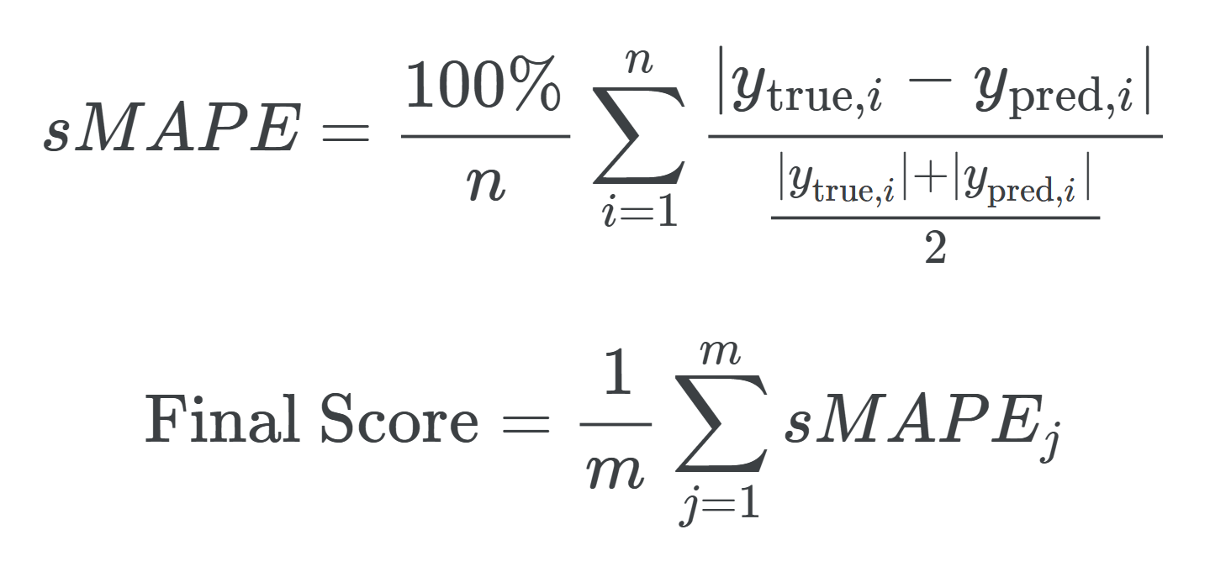
def smape(y_true, y_pred):
epsilon = tf.keras.backend.epsilon()
numerator = tf.abs(y_true - y_pred)
denominator = (tf.abs(y_true) + tf.abs(y_pred) + epsilon) / 2
return tf.reduce_mean(numerator / denominator) * 100

Data Analyzation

Primary Observations
- Dataset Contains daily weather variations for 30 kingdoms over 8 years.
- Some kingdoms appear to have temperature values ~300, which is unrealistic, this can be assumed that it was recorded in Kelvin.
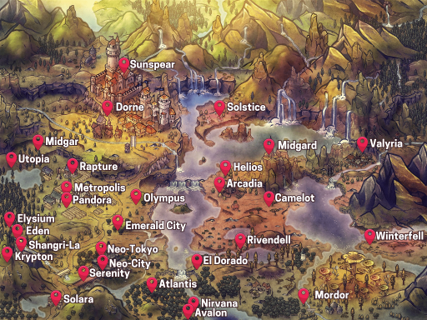

- Upon analyzing the given map for the given set of kingdoms and a randomly handpicked set of values, it’s clear that there is a strong connection between daily weather patterns and the location of the kingdoms, as they appear to have similar weather patterns when the kingdoms are close by.
- It’s also visible that latitude, longitude combination can be used to identify a kingdom uniquely (number of unique latitude, longitude pairs and number of kingdoms are equal)
- There are no missing values in the data set.

The following graph shows the weather patterns in the kingdom Arcadia through the 8 years (for easy processing of data date values are counted from 2018)

When visualizing data data will be filtered to a single kingdom (Arcadia - arbitrary chosen) to clearly visualize the data.
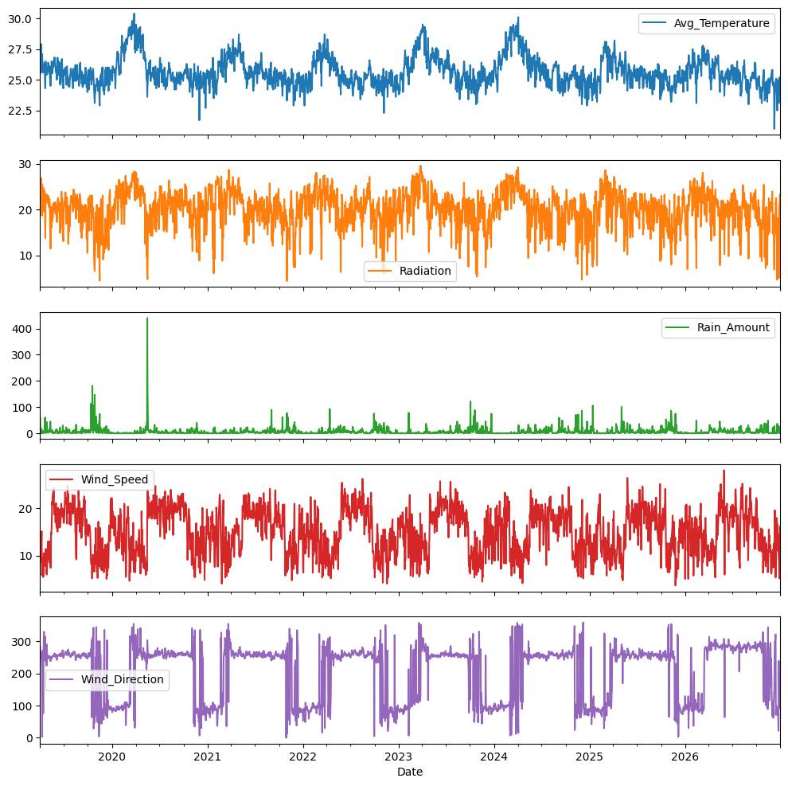
Most of the targets seem to have periodic features. But it’s hard to observe the Rain Amount (Because of outliers). There also seems to be a considerable amount of noise in the data. For accurate predictions they need to be cleaned.

Feature Engineering & Data Preparation

Data Preparation

- First step is to convert all the Kelvin values to Celcius values in the data frame. It was done but applying the following logic

df['Avg_Temperature'] = df['Avg_Temperature'].apply(lambda x: x - 273.15 if x > 200 else x)

- Then to accurately represent in a format easier for the model to learn targets Wind_Speed and Wind_Direction was processed into WindVX and WindVY.

df['WindVX'] = df['Wind_Speed'] * np.cos(np.radians(df['Wind_Direction']))
df['WindVY'] = df['Wind_Speed'] * np.sin(np.radians(df['Wind_Direction']))

- To improve the smoothness of the data a rolling mean was applied to the dataset. Initially the dataset is ordered by ID (dates are also arranged the same way so the dataset is initially ordered by Date) and then by kingdom. However if the rolling mean was applied on this condition it would represent incorrect results. Therefore, first it was grouped by kingdom and then sorted by Date first. Then it was again reordered to the original order (by ID). This step also helps with dealing with outliers in the Rain_Amount target.

df = df.sort_values(by=['kingdom', 'Date'], ascending=[True, True])
df[target] = df[target].rolling(window=20, center=True).mean()
df = df.sort_values(by=['ID'], ascending=[True])

Following graph shows the improved version of the dataset after smoothing (dataset is filtered by kingdom name Arcadia)

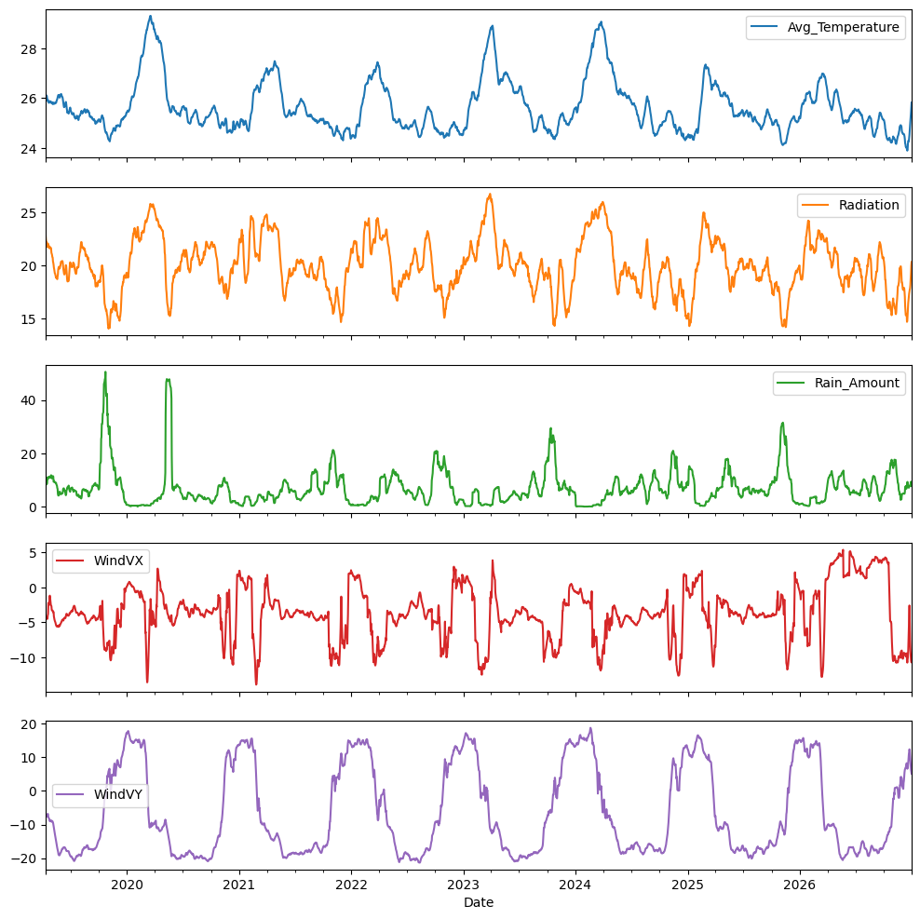

Feature Engineering

- According to the graphs it’s clear that the data has a 1-year seasonal pattern. However, to better understand the underlying periodic patterns of the dataset Fast Fourier Transformation is used to extract the most strong frequencies of the dataset in each aspect (for every kingdom x for every target). The following function was used to extract these data from the dataset.

def analyze_periods(data):
N = len(data)
fft_values = np.fft.fft(data)
freqs = np.fft.fftfreq(N, d=1)
magnitudes = np.abs(fft_values[:N//2]) / N
sorted_indices = np.argsort(magnitudes)[::-1]
periods = [1 / freqs[i] if freqs[i] != 0 else np.inf for i in sorted_indices]
return periods

Upon considering the data obtained by this approach, these are the most dominant periods in the dataset.

- 354 days (It’s not clear why the most dominant period is 354 days and not 365 days. However this is the result obtained through the FTT analysis)
- 188 days
- 177 days

To make use of these information features need to be added to the dataframe.

def add_period(df): # Index of the dataframe is the date
periods = [354, 188, 177]
for p in periods:
day_of_p = ((df.index - df.index.min()).days % p) + 1
df[f'sin_day_of_{p}'] = np.sin(2 * np.pi * day_of_p / p)
df[f'cos_day_of_{p}'] = np.cos(2 * np.pi * day_of_p / p)
return df

Sampling
- When training a model such as RNN (Recurrent Neural Network) it would be better to feed the data sequentially (sorted by date). So the testing data (tailing potion of the dataset) will not be seen by the model. This could produce incorrect results when the model is arranged in a way to predict the next timeframe data from the current timeframe data. Therefore, random sampling will be used.

Model Selection

Baseline
As a baseline simple prediction method using information obtained using FFT was used. The following functions were used to make the predictions.

def predict(data, n, th=100):
N = len(data)
fft_values = np.fft.fft(data)
freqs = np.fft.fftfreq(N, d=1)
extended_indexes = np.arange(N+1, N+1+n)
reconstructed_fet = np.zeros(len(extended_indexes), dtype=np.complex128)
threshold = th
for i, freq in enumerate(freqs[:N//2]):
if abs(freq) > threshold:
continue
amplitude = np.abs(fft_values[i]) / N
phase = np.angle(fft_values[i])
reconstructed_fet += amplitude * np.exp(1j * (2 * np.pi * freq * extended_indexes + phase))
reconstructed_fet = np.real(reconstructed_fet)
return reconstructed_fet
def predict_many(data, n, th=0.4):
return np.array([predict(fet, n, th) for fet in data])

Performance Evaluation
According to Kaggle this approach received sMAPE of 46.9 with evaluation dataset.

FNN (Feedforward Neural Network)
Next a FNN was used for an improved ability of pattern recognition.

model = Sequential([
Input(shape=(len(features),)),
Dense(64, activation='relu'),
BatchNormalization(),
Dense(32, activation='relu'),
Dropout(0.2),
Dense(16, activation='relu'),
Dense(1, activation='linear')
])

The optimizer used for this model is Adam, and loss function is Mean Squared Error (MSE), sMAPE was used as a metric.

Mean Squared Error (MSE) is more sensitive to outliers than Mean Absolute Error (MAE). However as graphed before because of the smoothing step most of the outliers were eliminated from the dataset. MSE provides more strict conditions for model evaluation.

Performance Evaluation
According to Kaggle this approach received sMAPE of 45.17 with evaluation dataset.

CNN-LSTM Network
CNN - Convolutional Neural Network, LSTM - Long Short-Term Memory
Since this model is expected to predict time series data, it’s much better to use Convolutional Layer for feature extraction and LSTM layer for learning temporal dependencies.

model = Sequential([
Input(shape=(len(features),)),
Conv1D(filters=64, kernel_size=3, activation='relu', padding='same'),
MaxPooling1D(pool_size=2),
LSTM(32, return_sequences=False),
Dense(16, activation='relu'),
Dense(1, activation='linear')
])

The optimizer used for this model is Adam, and loss function is Mean Squared Error (MSE), sMAPE was used as a metric.

Performance Evaluation
According to Kaggle this approach received sMAPE of 43.05 with evaluation dataset.

Interpretability & Business Insights

As weather patterns become more unpredictable, particularly in agriculture, accurate forecasting is essential. In Sri Lanka, unexpected weather events, such as unanticipated rainfall, often disrupt harvests, leading to poor yields. Farmers typically struggle to adapt to these changes due to insufficient timeframes for planning.

By providing reliable long-term weather predictions, especially for the upcoming months, farmers can better plan their activities, minimizing crop loss and improving harvests. This model would help farmers adjust their planting and harvesting schedules based on forecasted weather patterns, ultimately supporting more efficient agricultural practices.

To further improve the model, incorporating agricultural-specific data could provide even more accurate insights. Deploying the forecasting tool on a mobile app or website would make it easily accessible to farmers, helping them stay informed and adapt to changing conditions.

Innovation & Technical Depth

In this project, several innovative techniques were applied to improve model accuracy and efficiency. A key approach was the use of Fourier Transform (FFT) to identify dominant seasonal patterns in the weather data. By extracting the most prominent frequencies, we were able to introduce periodic features into the model, allowing it to better capture annual cycles in weather conditions. Additionally, we applied advanced feature engineering by transforming wind speed and direction into WindVX and WindVY components, making it easier for the model to understand directional patterns.

The architecture of the model also incorporated Convolutional Neural Networks (CNN) combined with Long Short-Term Memory (LSTM) layers. This hybrid approach allowed us to extract meaningful features from the data and learn temporal dependencies, crucial for accurate time-series forecasting. To further enhance model performance, we utilized rolling mean smoothing techniques, reducing noise in the dataset and enabling the model to focus on long-term trends, especially in variables like Rain Amount.

Overall, these innovations in feature engineering and model architecture significantly boosted the accuracy of the predictions while ensuring the model remained computationally efficient.

Conclusion

In conclusion, this project successfully developed a time series forecasting model to predict key environmental variables, including temperature, wind speed, radiation, and rainfall for the Harveston region. The model that combined Convolutional Neural Networks (CNN) with Long Short-Term Memory (LSTM) layers performed the best, achieving an sMAPE score of 43.05. This approach was more effective than others, such as the Feedforward Neural Network (FNN), due to its ability to capture both spatial features and temporal dependencies in the data.

Challenges during the project included handling noisy data, particularly with outliers in the Rain Amount variable, which required careful data preprocessing and smoothing. Additionally, understanding and predicting the complex seasonal patterns posed difficulties, as variations in weather data could vary significantly from year to year.

For future improvements, exploring ensemble learning techniques could enhance model performance by combining multiple model outputs for more robust predictions. Additionally, improving the data quality by incorporating more granular and diverse datasets could further refine accuracy. Expanding the model to include real-time forecasting capabilities could also be a key area for enhancement, allowing for more dynamic and adaptive predictions in the future.

